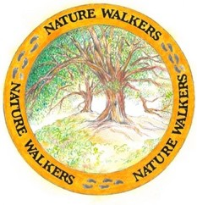

Nature Walkers
Membership Form

Our mission:
Nature Walkers is an organization of Rossmoor residents who value the scientific evidence that appreciation of nature is important in maintaining and improving physical and mental health. Our mission is to advance appreciation of nature and to provide films and other opportunities to socialize, meet new friends and strengthen our community.

Please fill out this entire form if you are a new member.
If you are a returning member, we just need your name and dues information and DATE.
First name Last name
(Please print clearly)
Address Entry

Email

Cell # ( )

New Member? Returning Member?

DUES
Dues cover our expenses for Peacock Hall rental, website and announcements, handouts, displays, events (renting venues, films and paying for guest speakers)

Membership dues for 1 year are $10.00 Cash only Date Paid

DON’T FORGET THE DATE!
Place in the Nature Walkers mailbox in the Gateway Offices OR
Bring to the Nature Walkers Movie held on the 3rd Wednesday of the month

You will be added to our email list and will receive notification of all of our activities.

Please specify your areas of interest:

